

WEEKLY TO DO LIST

WEEK/DATE:
MONDAY
PRIORITIES

TUESDAY

TO DO LIST
WEDNESDAY

THURSDAY

NOTES
FRIDAY

SATURDAY

SUNDAY

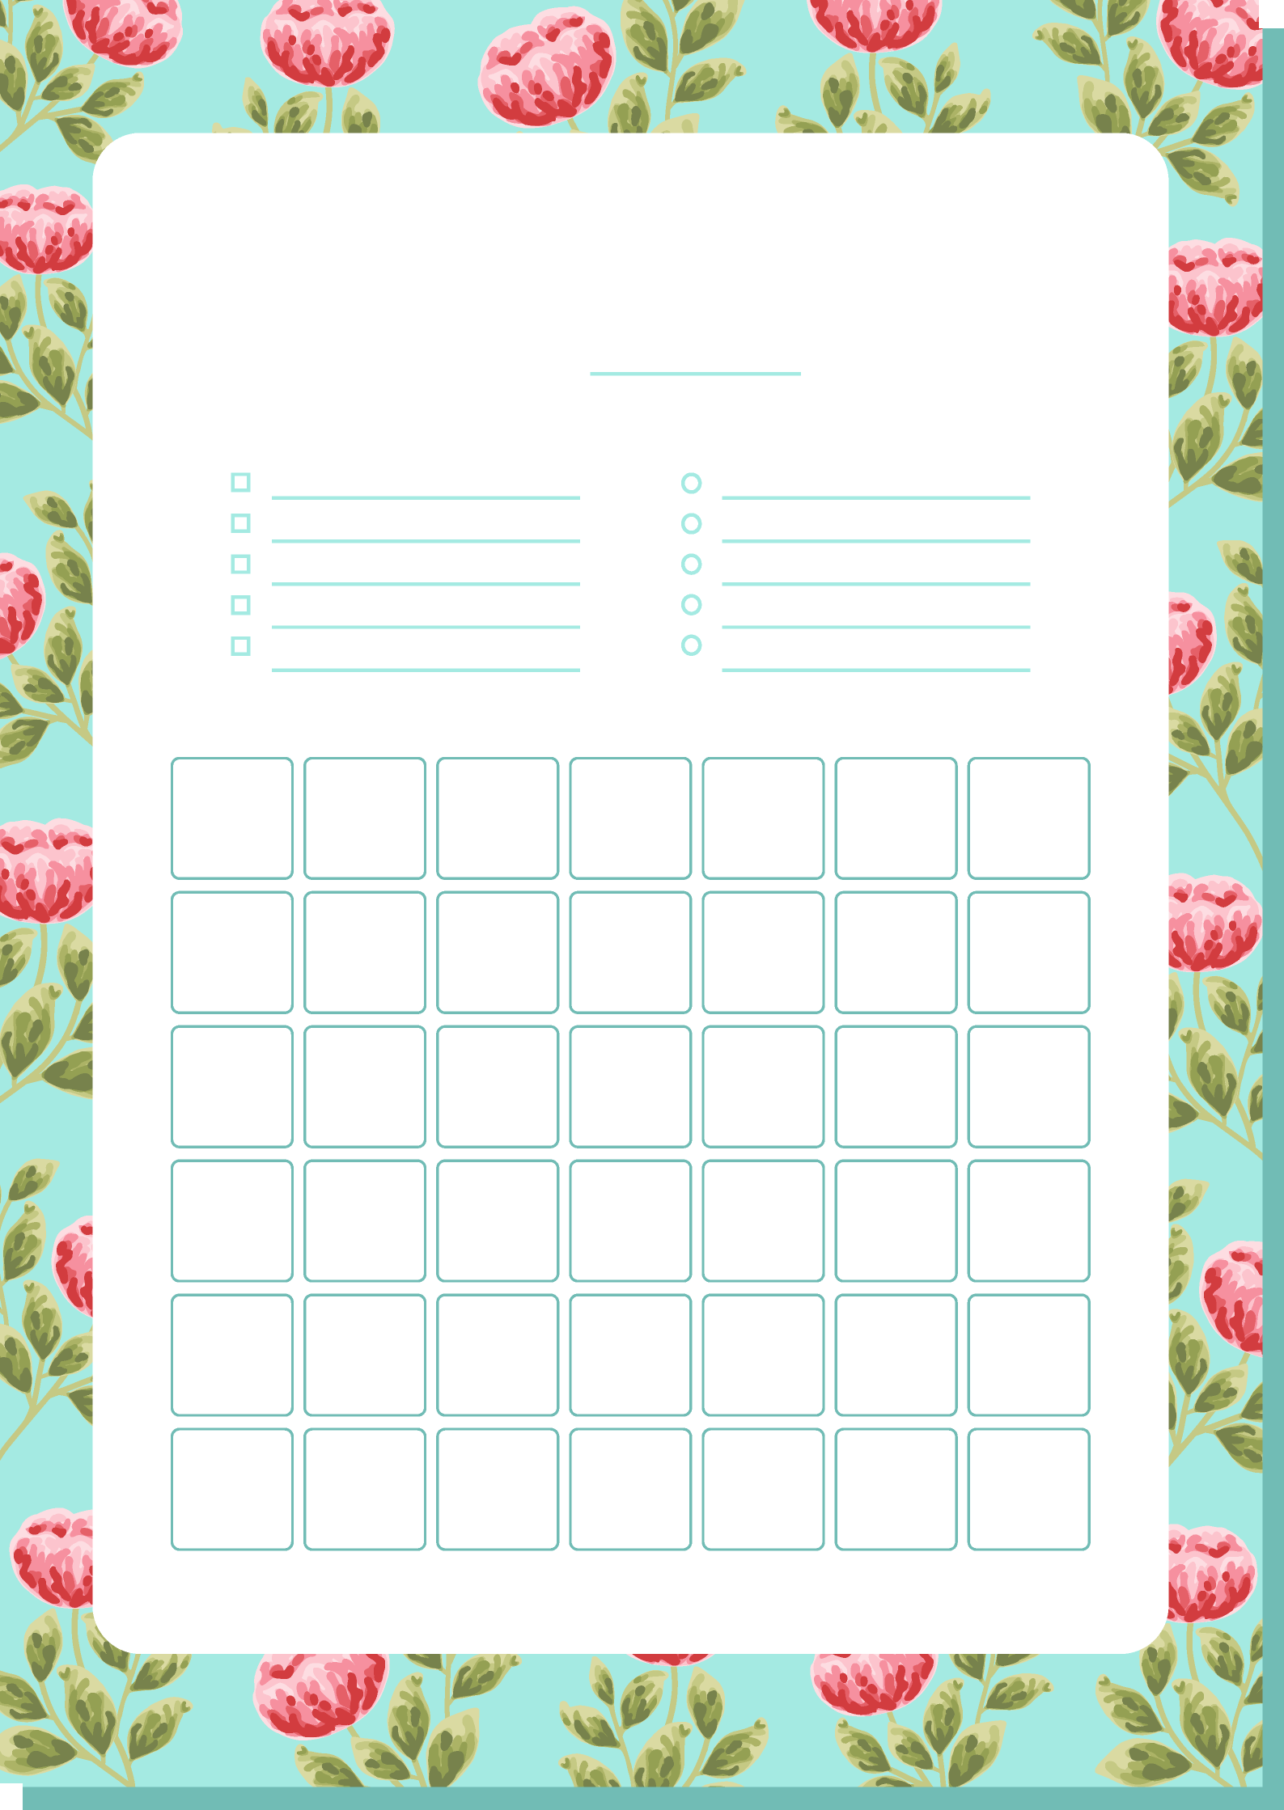
THURSDAY
SUNDAY
SATURDAY
FRIDAY
WEDNESDAY
TUESDAY
MONDAY
TO DO LIST
PRIORITIES
WEEK/DATE:
MONTHLY TO DO LIST

