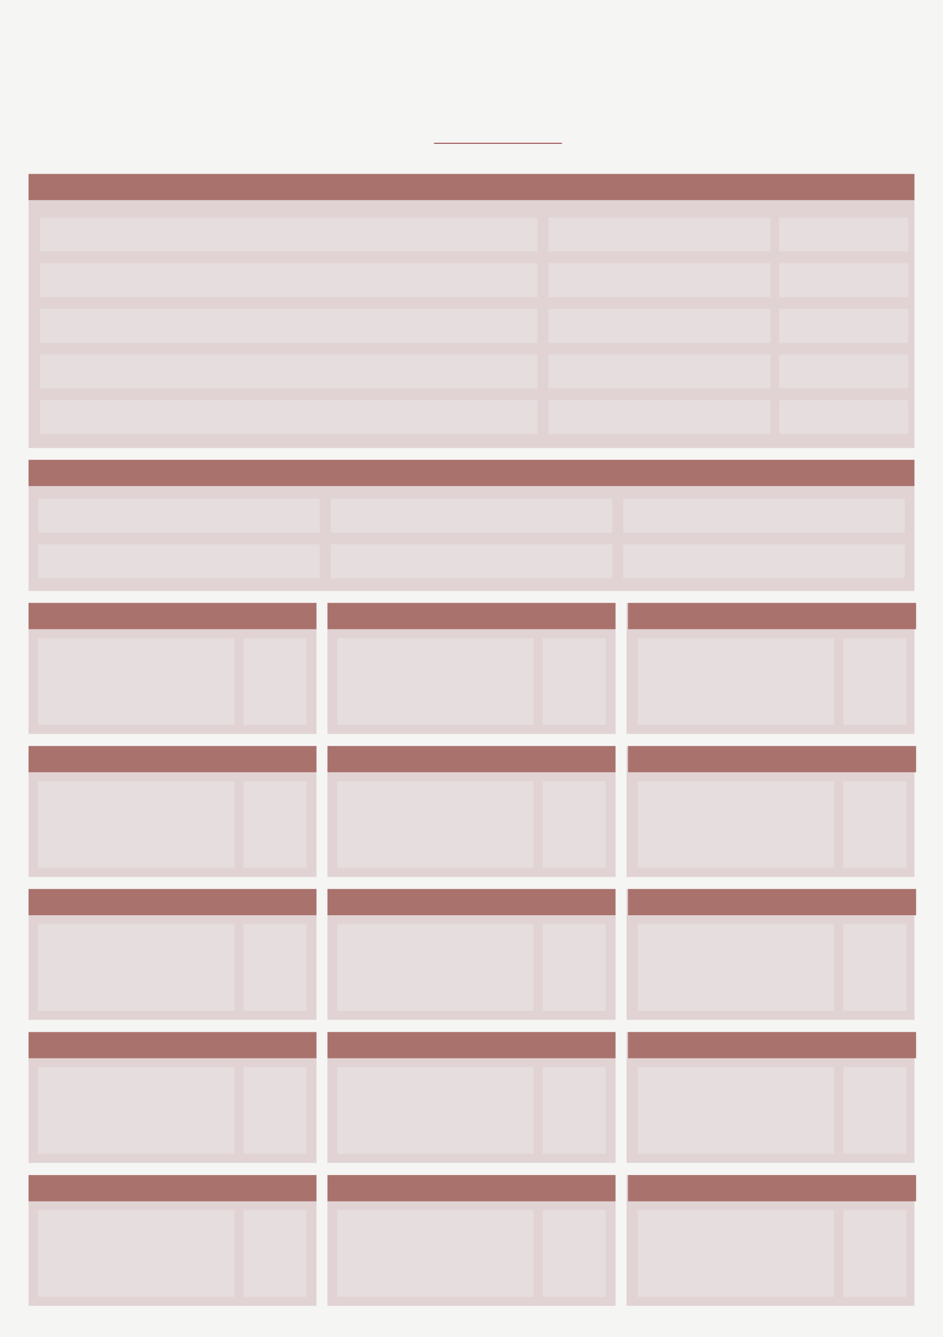
Bi-Weekly To-Do List
SUNDAY
SATURDAY
FRIDAY
THURSDAY
WEDNESDAY
TUESDAY
MONDAY
SUNDAY
FRIDAY
SATURDAY
THURSDAY
WEDNESDAY
TUESDAY
MONDAY
NOTES
MEAL PLAN
TOP PRIORITY FOR TODAY:
CAN WAIT UNTIL TOMORROW
I AM GRATEFUL FOR
DATE:

