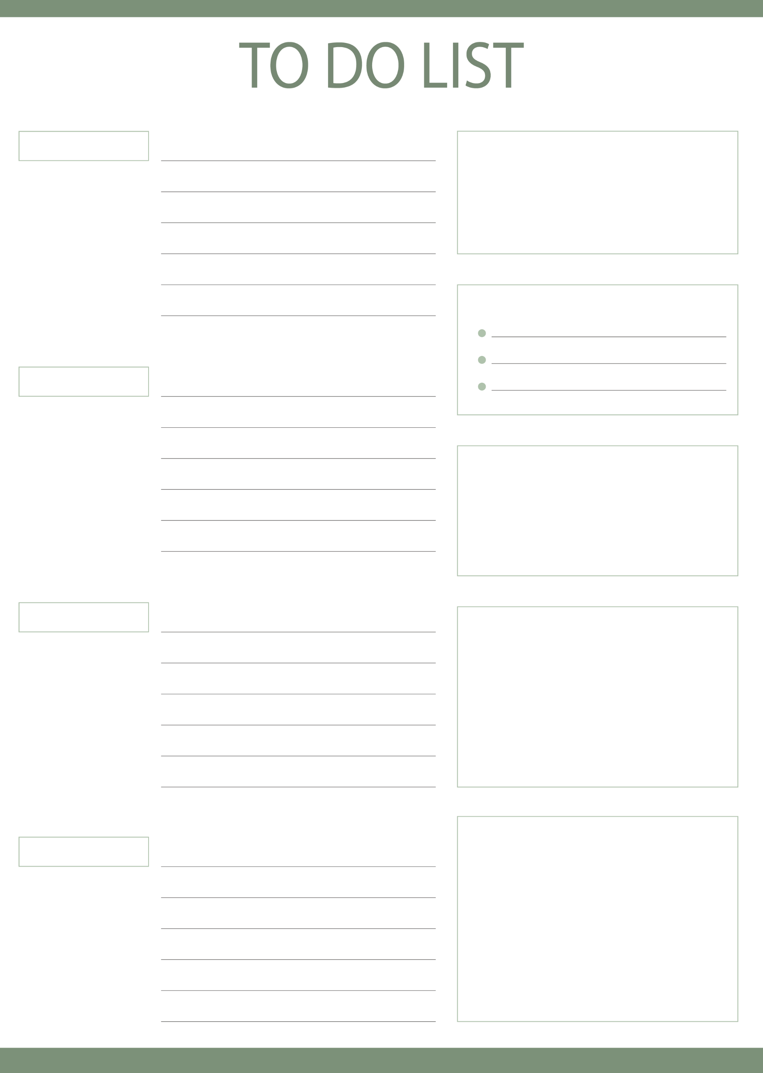
MORNING
TODAY’S GOAL
NOTE
MEALS
DAILY QUOTE
TOP 3 TASKS
AFTERNOON
EVENING
NIGHT

