


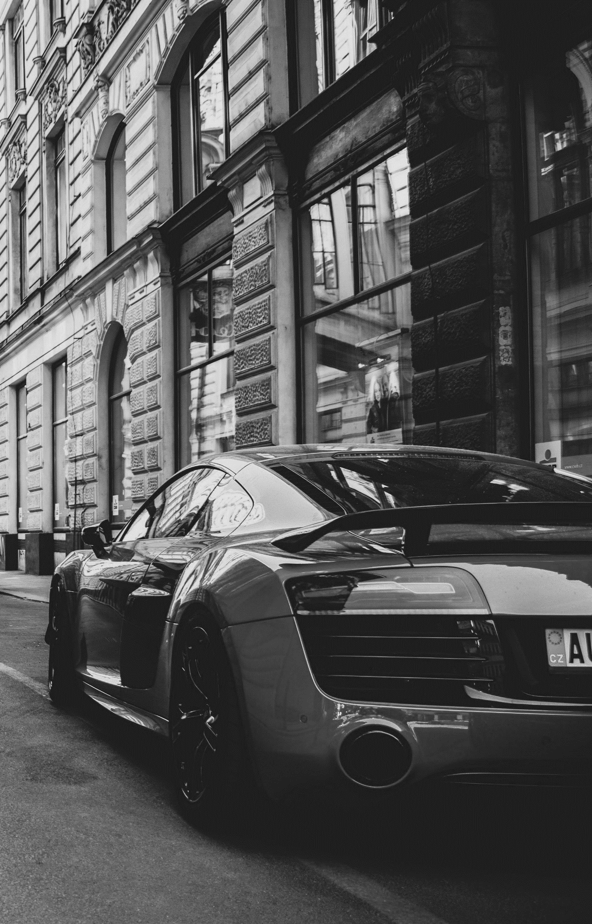
Address: H&H Company, Sixth Avenue, Jackson City, NY
Call Number: 000-000-0000
Website: www.yourwebsite.com
PREMIUM WASH
Loren Ipsum $0.00
Loren Ipsum $0.00
Loren Ipsum $0.00
Loren Ipsum $0.00
Loren Ipsum $0.00
Loren Ipsum $0.00

STANDARD WASH
Loren Ipsum $0.00
Loren Ipsum $0.00
Loren Ipsum $0.00
Loren Ipsum $0.00
Loren Ipsum $0.00

BASIC WASH
Loren Ipsum $0.00
Loren Ipsum $0.00
Loren Ipsum $0.00
CAR
DETAILING
PRICELIST
H & H Company

