
PRODUCT
Price List
Company Name
Best Furniture in Town!
(Your slogan - additional description)
 |  |  |  | PRODUCT #1 |  |  |  | PRODUCT #2
 |  |  |  | Description: |  |  |  | Description:
 |  | 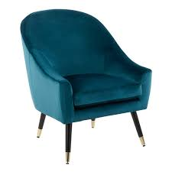 |  | Lorem ipsum dolor sit amet, consectetuer adipiscing elit. Maecenas porttitor congue massa.  Fusce posuere, magna sed pulvinar ultricies, purus lectus malesuada libero, sit amet commodo magna eros quis urna. Nunc viverra imperdiet enim. |  | 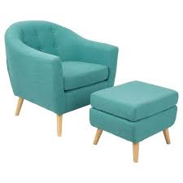 |  | Lorem ipsum dolor sit amet, consectetuer adipiscing elit. Maecenas porttitor congue massa.  Fusce posuere, magna sed pulvinar ultricies, purus lectus malesuada libero, sit amet commodo magna eros quis urna. Nunc viverra imperdiet enim.
 |  |  |  | Price: |  |  |  | Price:
 |  |  |  | $338.00 |  |  |  | $215.00
 |  |  |  | PRODUCT #3 |  |  |  | PRODUCT #4
 |  |  |  | Description: |  |  |  | Description:
 |  | 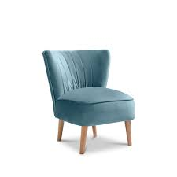 |  | Lorem ipsum dolor sit amet, consectetuer adipiscing elit. Maecenas porttitor congue massa.  Fusce posuere, magna sed pulvinar ultricies, purus lectus malesuada libero, sit amet commodo magna eros quis urna. Nunc viverra imperdiet enim. |  | 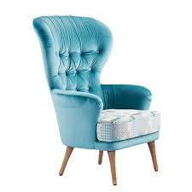 |  | Lorem ipsum dolor sit amet, consectetuer adipiscing elit. Maecenas porttitor congue massa.  Fusce posuere, magna sed pulvinar ultricies, purus lectus malesuada libero, sit amet commodo magna eros quis urna. Nunc viverra imperdiet enim.
 |  |  |  | Price: |  |  |  | Price:
 |  |  |  | $107.00 |  |  |  | $95.00
 |  |  |  | PRODUCT #5 |  |  |  | PRODUCT #6
 |  |  |  | Description: |  |  |  | Description:
 |  | 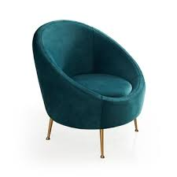 |  | Lorem ipsum dolor sit amet, consectetuer adipiscing elit. Maecenas porttitor congue massa.  Fusce posuere, magna sed pulvinar ultricies, purus lectus malesuada libero, sit amet commodo magna eros quis urna. Nunc viverra imperdiet enim. |  | 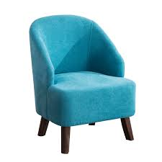 |  | Lorem ipsum dolor sit amet, consectetuer adipiscing elit. Maecenas porttitor congue massa.  Fusce posuere, magna sed pulvinar ultricies, purus lectus malesuada libero, sit amet commodo magna eros quis urna. Nunc viverra imperdiet enim.
 |  |  |  | Price: |  |  |  | Price:
 |  |  |  | $1,455.00 |  |  |  | $399.00

(1234) 111 5259 4422
info@companyname.com

